Divide and Conquer – Searching & Basic Problems
Binary Search, Finding Maximum and Minimum using Divide and Conquer Dr. U. Samson Ebenezar
Question 1: Search an Element in a Sorted Array
Given a sorted array of integers and a key value, use the Binary Search (Divide and Conquer) method to determine whether the key is present in the array. If found, print its position; otherwise, print "Element not found".
Test Case 1
Input
5
10 20 30 40 50
30
Expected Output
Element found at position 3
Test Case 2
Input
5
10 20 30 40 50
25
Expected Output
Element not found
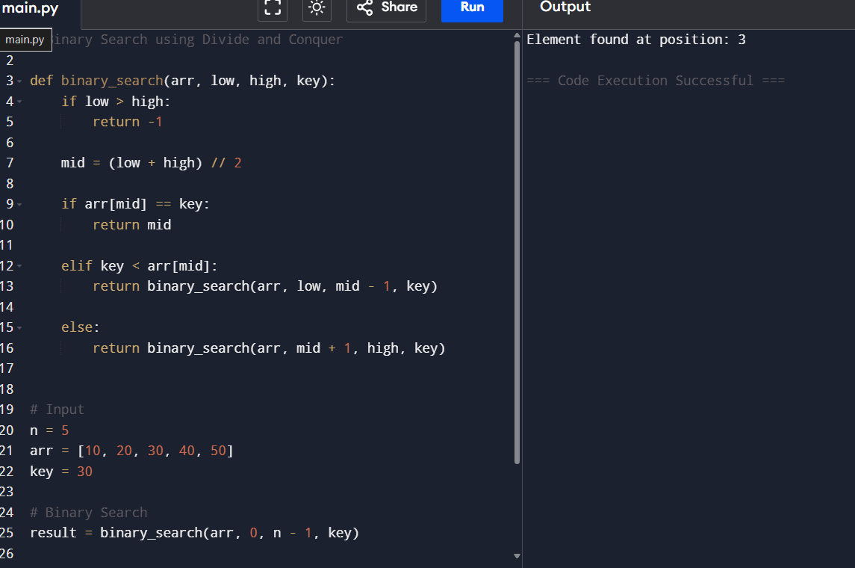

Question 2: Find the Index of a Given Number
Given a sorted array and a target number, find the index of the target using Binary Search. Assume array indexing starts from 0.
Test Case 1
Input
6
2 4 6 8 10 12
8
Expected Output
Index = 3
Test Case 2
Input
6
2 4 6 8 10 12
5
Expected Output
Index = -1
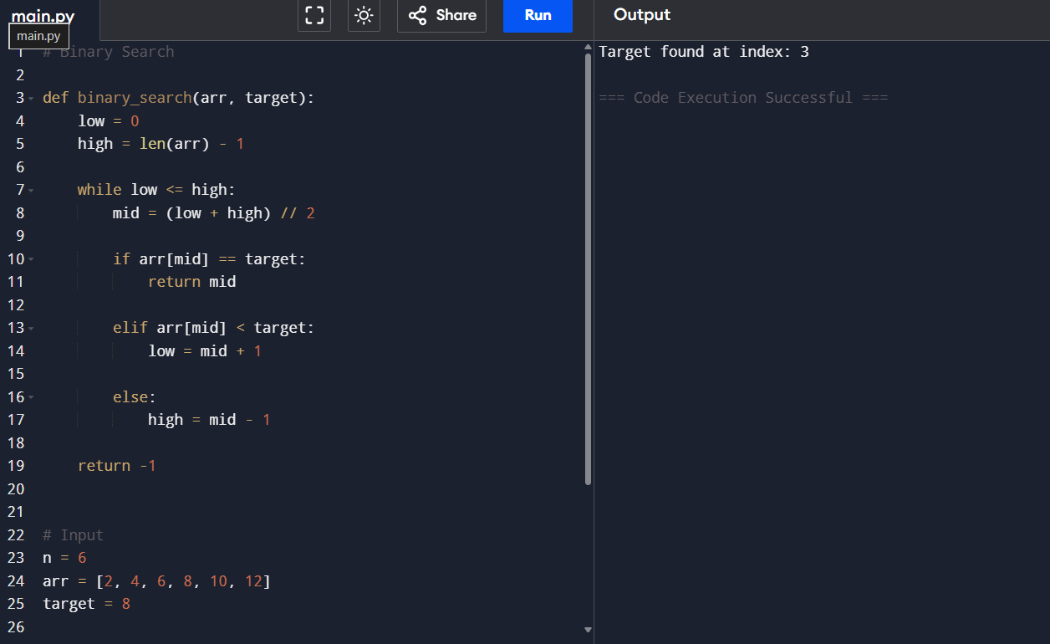
Question 3: Count the Number of Iterations in Binary Search
Given a sorted array and a key, perform Binary Search and display the number of iterations required to find the element.
Test Case 1
Input
7
5 10 15 20 25 30 35
25
Expected Output
Element found
Iterations = 2
Test Case 2
Input
7
5 10 15 20 25 30 35
40
Expected Output
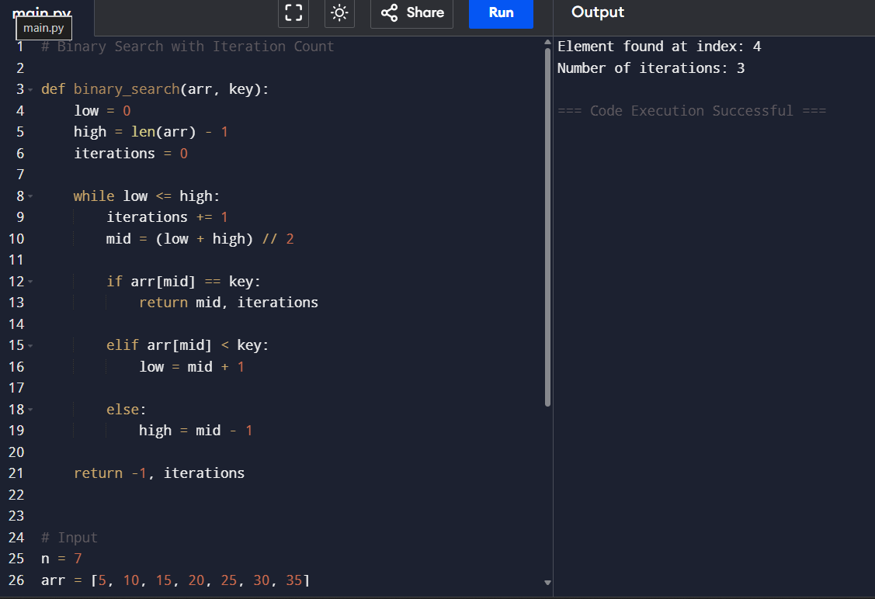
Element not found
Iterations = 3
Question 4: Find the First Occurrence of an Element
Given a sorted array containing duplicate elements, find the first occurrence of a given key using Binary Search.
Test Case 1
Input
8
1 2 2 2 3 4 5 6
2
Expected Output
First occurrence at index 1
Test Case 2
Input
8
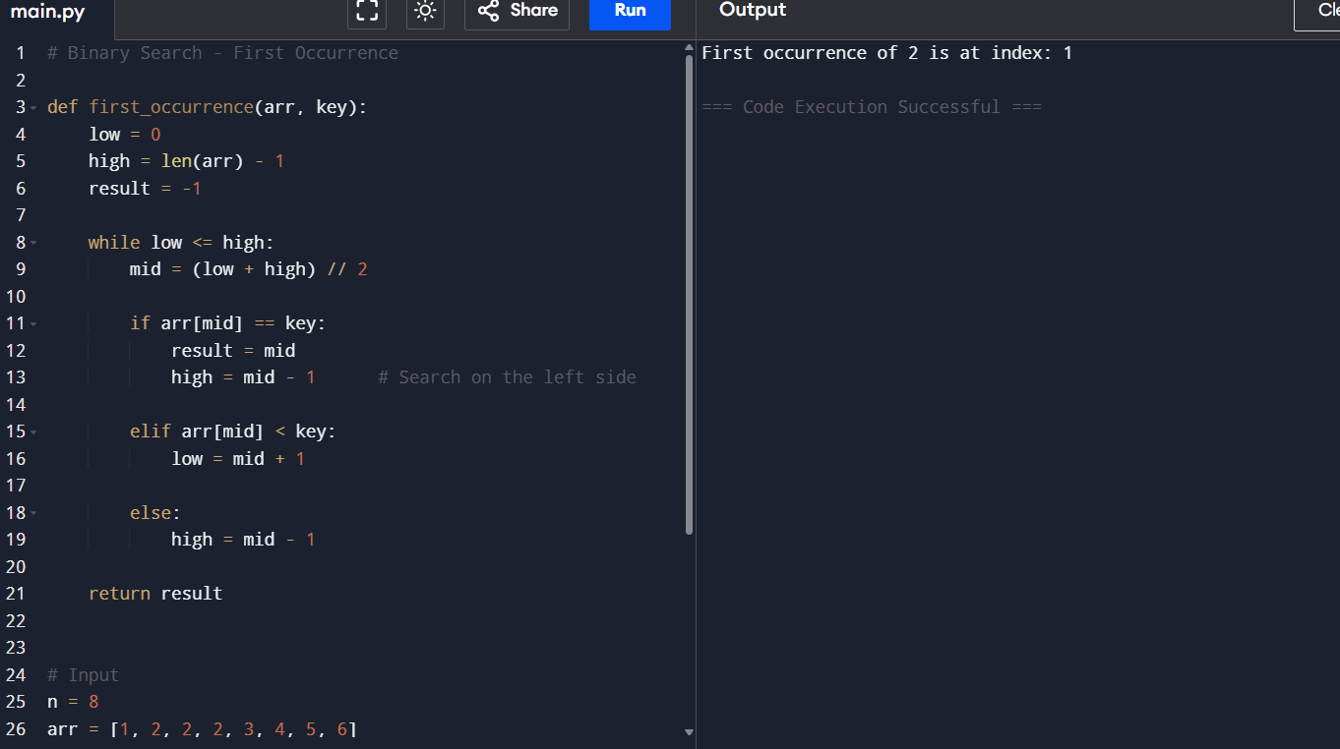
1 2 2 2 3 4 5 6
7
Expected Output
Element not found
Question 5: Find the Last Occurrence of an Element
Given a sorted array containing duplicate elements, find the last occurrence of a given key using Binary Search.
Test Case 1
Input
8
1 2 2 2 3 4 5 6
2
Expected Output
Last occurrence at index 3
Test Case 2
Input
8
1 2 2 2 3 4 5 6
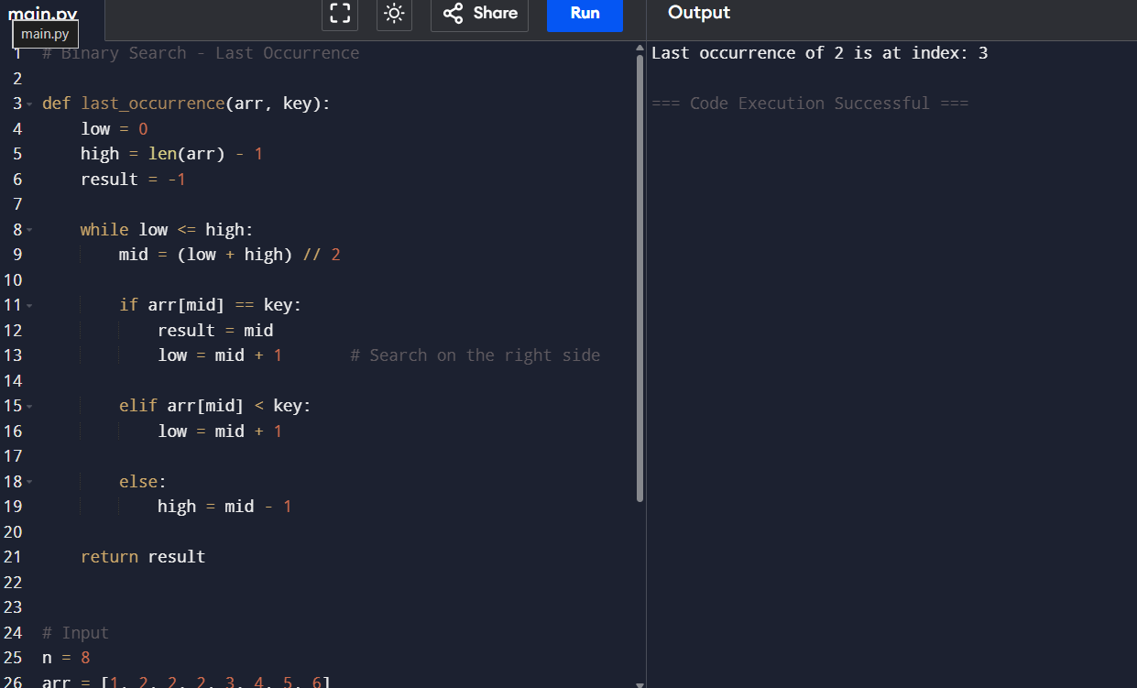
9
Expected Output
Element not found
Question 6: Highest and Lowest Temperature Recorded
Expected Output
Minimum Temperature = 25
Maximum Temperature = 37
Question 6: Best and Worst Student Marks
A teacher wants to identify the highest and lowest marks scored in a class using Divide and Conquer.
Input
8
78 92 65 88 95 72 81 69
Expected Output
Minimum Mark = 65
Maximum Mark = 95
Question 8: Stock Price Analysis
An investor wants to know the minimum and maximum stock prices recorded during a trading week.
Input
6
450 520 480 610 430 590
Expected Output
Minimum Stock Price = 430
Maximum Stock Price = 610
Question 9: Fastest and Slowest Race Times
A sports analyst needs to find the fastest (minimum) and slowest (maximum) race completion times.
Input
9
14 12 18 11 15 13 17 16 10
Expected Output
Fastest Time = 10
Slowest Time = 18
Question 10: Largest and Smallest Building Heights
An urban planner is analyzing building heights in a city block and wants to determine the tallest and shortest buildings.
Input
10
120 150 98 175 140 165 110 190 130 145
Expected Output
Minimum Height = 98
Maximum Height = 190
